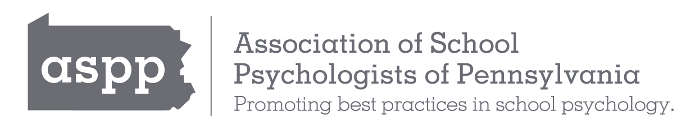
On behalf of the Association of School Psychologists of Pennsylvania (ASPP) Membership Services Committee, thank you for the incredible work that you do! Rising above the many challenges faced by our students, families, and school systems, our members have demonstrated resilience and continued to serve the children and youth of Pennsylvania. Collectively, our members have achieved far more together than any one single effort could accomplish.

Advocacy in Action: Supporting Members
ASPP has continued to advance numerous initiatives, promoting school psychology across Pennsylvania. We are committed to supporting our members so that they are well-equipped to serve our youth, schools, families, and communities. Dedicated to this mission, ongoing advocacy endeavors include the following: advocating for and securing paid school psychology internships in Pennsylvania, facilitating modifications in the Pennsylvania School Code to include state-paid internships, pushing for a loan forgiveness bill, and achieving NCSP parity, recognizing NCSP as a pathway for certification in Pennsylvania from other states.

Professional Development
Dedicated facilitating professional growth, ASPP hosted a successful and engaging fall conference. ASPP is committed to high-quality professional development and all members have access to discounted rates for both the annual fall workshops and spring conferences. Additional benefits include the ASPP Insight Publication and members only resources. With a focus on being responsive to the needs of our members and our Pennsylvania schools, ASPP provides up-to-date training on research-based practices to support school systems, students, educators, and caregivers.

Community Building
This year, membership has grown, and relationships have been a priority. ASPP has continued to focus on relationship development and belonging for its members. Through regional membership engagement initiatives, members have come together to build community. Members continue to be highlighted for the work they do in our monthly membership ASPP accolades.

Organizational Development
ASPP has focused on restructuring the Board to increase organizational capacity and has prioritized establishing a leadership pipeline. Providing increased accessibility to members through website redesign and enhanced social media communication has been a priority.

Membership
Your membership is crucial in supporting our advocacy work and promoting school psychology in Pennsylvania. For only $50.00 (Early Career Year Member) or $85.00 (Full Member) per year, you can gain access to extensive resources and professional development opportunities that support the academic, social, emotional, and behavioral needs of your students. And finally, ASPP is excited to share that graduate student members can join for free this year!

Thank you again for all the work you are doing to connect with our students, their families, and schools. Please renew your membership by logging onto your account on the ASPP website, or you may print out a membership registration form and mail it in.

Please renew your membership by logging onto your account on the ASPP website or you may print out a Membership Renewal Form and mail it in.

With appreciation for all that you do,

Dr. Jessica K. Dirsmith, NCSP  ASPP Membership Committee Chair |  | Dr. Amber Sessoms, NCSP  ASPP President |  | Shradha Gera, Ed.S., NCSP  ASPP President-Elect

